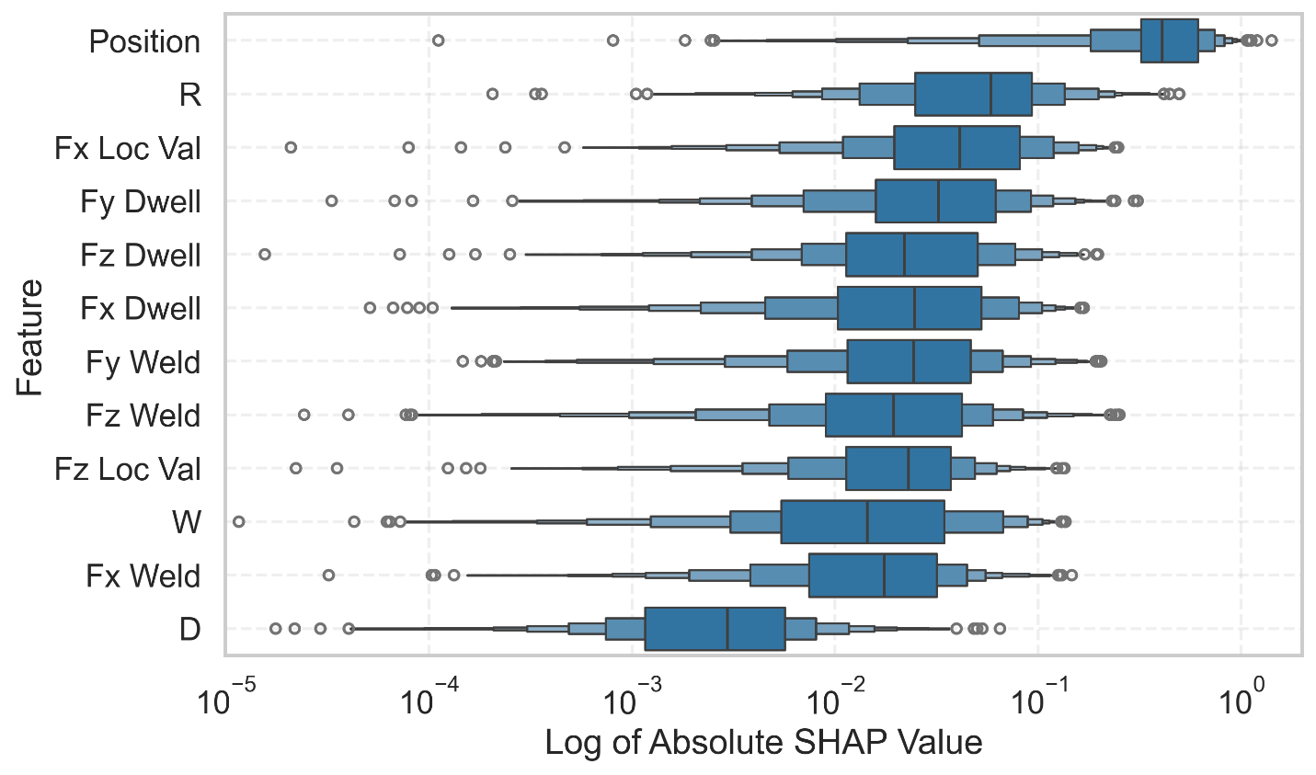Updated 2026-03-03
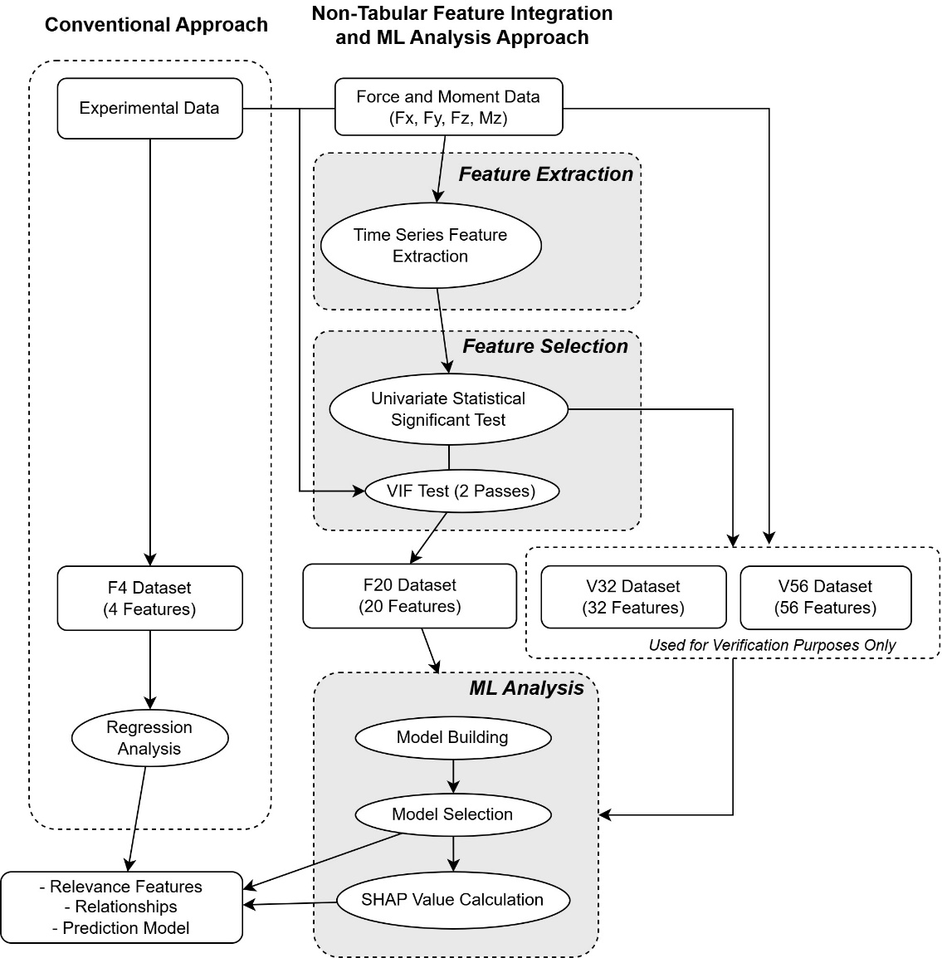
This study compares a conventional experimental data analysis workflow with a proposed feature-based integration and machine learning approach. In the conventional methodology, only the control variables—welding parameters $W$, $D$, $R$, and the measurement position—are used as predictors. These variables form the F4 dataset, which consists of four input features and three residual stress responses. Standard regression analysis is then applied to this dataset to evaluate feature significance, estimate regression coefficients that describe the trends, and construct prediction models for the stress values. Such process is summarized in Fig. XX.
In the proposed Non-Tabular Feature-Integration and ML Analysis Approach, non-tabular experimental data are incorporated by transforming time-series measurements of forces and moment ($F_{x}$, $F_{y}$, $F_{z}$, and $M_{z}$) into engineered features, followed by ML analysis to evaluate feature significance from constructed prediction model. The processing steps are shown in Fig. XX with the following details.
Freature Extraction
In this process, candidate features are first derived by computing window‑averaged values of the time‑series data at the stress measurement locations, yielding four initial features. Additional time-series descriptors are then extracted using the TS-Fresh library; specifically, the descriptors are obtained from the time series that are partitioned into dwell and weld regions (a total of 8 regions) so that the importance of features in each region can be investigated separately. Each region yield approximately 700 features which results in around 5,600 candidate features.
Feature Selection
The feature selection process aims to reduce the high dimensionality of the extracted features. First, univariate statistical significance tests are conducted for each of the three stress responses, and features are ranked by their p-values, producing 24 separate ranking lists. In the initial reduction stage, the number of top-ranked features to retain from each list is specified. For instance, setting $MF=1$yields up to 24 sets of candidate features (fewer if duplicate features appear across lists). However, these candidate features may still exhibit correlation, leading to multicollinearity that can distort the interpretation of feature importance. To address this, a two-stage variance inflation factor (VIF) analysis is applied: the first pass removes redundant features among time-series-derived features, and the second combines the remaining time-series features with the original control variables. A VIF threshold of 5 is chosen as a conservative limit. The resulting VIF-filtered dataset, referred to as F20, contains 20 unique features after accounting for duplicate columns. Since VIF filtering may sometimes reduce model performance, two additional datasets without VIF filtering are also constructed for comparison: V32, with 32 features, and V56, with 56 features.
ML Analysis
All datasets (F4, F20, V32, and V56) are subsequently processed through a machine learning pipeline. The process consists of model building, model selection and SHAP value calculations. For the model building process, eight regression models are trained: ElasticNet linear regression, support vector regression with a nonlinear kernel, k-nearest neighbors regression, and four tree-based models—decision tree, random forest, gradient boosting, and XGBoost—as well as a transformer-based tabular model (TabPFN). The first seven models represent conventional machine learning approaches that collectively span a range of predictive methods. Among these, tree-based models, particularly XGBoost, are well-recognized for delivering state-of-the-art performance on tabular datasets. The final model, TabPFN, introduces a transformer-based approach in which the model has been pretrained on extensive synthetic data and thus eliminates the need for task-specific hyperparameter tuning. Its inclusion serves to assess the applicability and effectiveness of this new generation of transformer-based models in tabular regression tasks. The results obtained from the V32 and V56 datasets are used to verify that the aggressively VIF‑filtered F20 dataset does not suffer from substantially degraded predictive performance, thereby supporting the reliability of subsequent feature importance analyses conducted on F20.
Model selection is performed based on the coefficient of determination ($R^{2}$). To address the limited sample size, each model is repeatedly trained on multiple data partitions. Specifically, five distinct train–test splits are generated and, for each split, the model hyperparameters are tuned using a 4-fold cross-validation scheme, allowing each split to yield its own optimized hyperparameters. The test $R^{2}$from each split is recorded, so model performance is characterized as a distribution of $R^{2}$values rather than a single point estimate. This procedure reduces sensitivity to any particular train–test split and provides a more robust assessment of predictive performance.
The next step is to analyze feature importance using SHAP (SHapley Additive exPlanations) values to quantify the relevance of each feature and interpret its individual contribution to the predicted residual stress responses. SHAP values are employed because they capture nonlinear effects more faithfully than simple regression coefficients or impurity-based importance measures. For each selected model, SHAP values are computed from multiple sets of optimal hyperparameters: the model is retrained on the full dataset for each hyperparameter configuration, and SHAP values are then evaluated over all samples. Furthermore, the additivity property of SHAP values enables aggregation of groups of time-series features—which may be difficult to interpret individually—into meaningful composite attributions, thereby providing a clear baseline for the overall importance of time-series information in each region.
Model development is conducted in Python using libraries such as scikit-learn, XGBoost, and TabPFN, with Optuna employed for hyperparameter optimization. SHAP values are computed using the shap library.
Results and Discussion
Conventional Approach
We first report the results from the conventional regression analysis. The fitted model is statistically significant (overall F-test $p=1.1×{10}^{-26}$) with $R^{2}=0.290$, indicating that approximately 30% of the variance in the data is explained by the model. Based on coefficient significance at the 5% level, the variables Position (negative coefficient), R (negative coefficient), and W (positive coefficient) are identified as significant predictors. No statistically significant regression models are obtained for predicting the residual stress values on the 5051 or 6061 sides. These results indicate a statistically significant association between Position, R, and W and the residual stress in the center region. In contrast, the dwell time D does not exhibit a significant effect on the central stress. If compressive stress is desired, these findings suggest that favorable stress states are achieved toward the end of the weld when using a high rotational speed and a low welding (traverse) speed.
Non-Tabular Feature-Integration and ML Analysis Approach

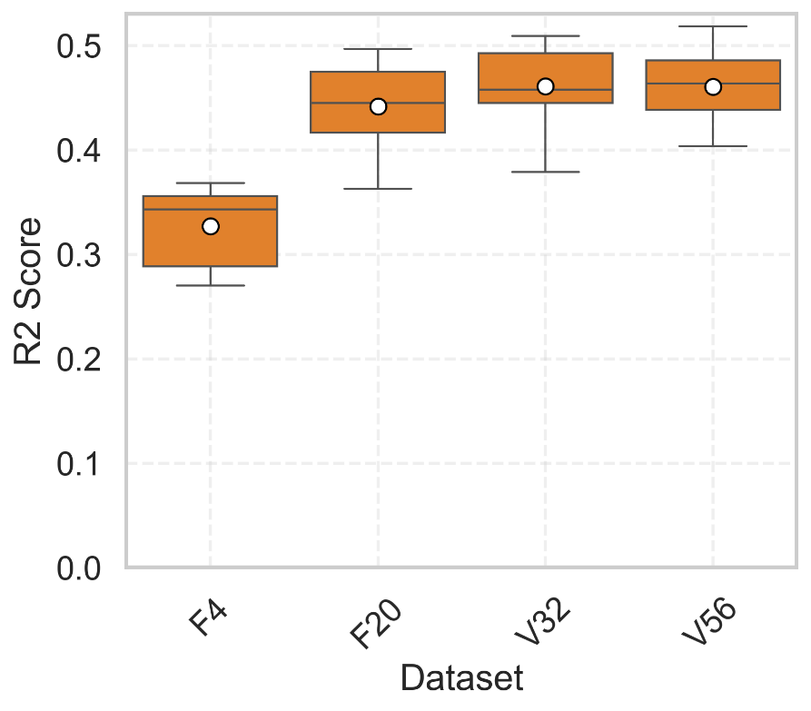
The results from model development across all eight machine learning models are summarized in Fig. XX, where we report only the models predicting the center residual stress; models for the 5052 and 6061 sides are omitted due to their low $R^{2}$, consistent with the regression analysis in the previous section. For the F4 dataset, the mean $R^{2}$is 0.33, which is slightly higher than that of the conventional linear regression model, reflecting the ability of nonlinear models to capture additional structure in the data. A substantial improvement in $R^{2}$is observed when using the F20 dataset, where the mean $R^{2}$increases to 0.44, indicating that the added features derived from non-tabulated data enable the models to explain a larger fraction of the variance and thereby support more reliable feature-importance analysis. This also suggests that feature engineering has a greater impact on predictive performance than the particular choice of model. Further increases in feature dimensionality for the V32 and V56 datasets do not yield meaningful gains in $R^{2}$, confirming that the VIF-based reduction in F20 does not significantly compromise model predictability.

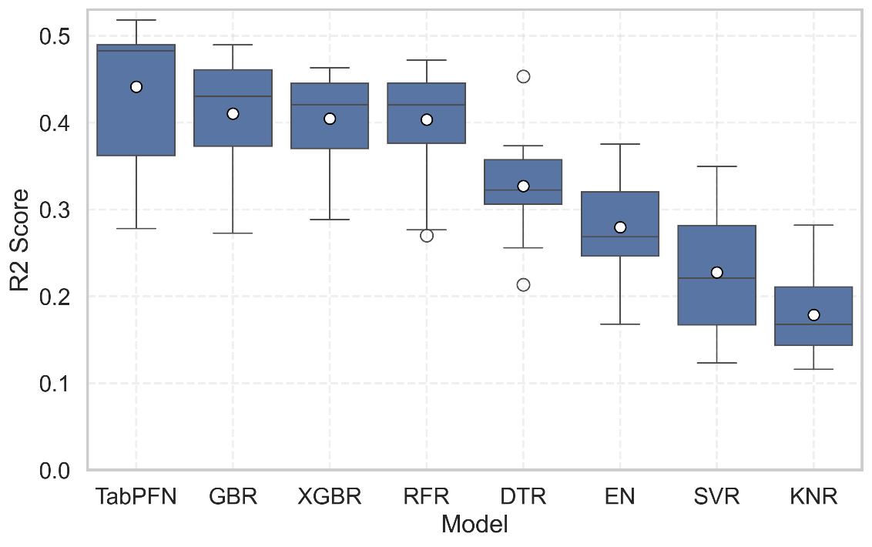
Fig. XX presents the performance of the eight models on the F20 dataset, where the spread of $R^{2}$values clearly illustrates the variability arising from different data partitions. Relying on a single train–test split could therefore lead to a misleading assessment of model performance. The top-performing models are TabPFN, GBR, XGBR, and RFR, with the strong results of the tree-based ensemble models (GBR, XGBR, RFR) aligning with their established status as state-of-the-art methods for tabular data. Notably, TabPFN achieves the highest mean $R^{2}$, indicating that this pretrained transformer-based approach is a promising candidate for high-performance modeling via transfer learning.

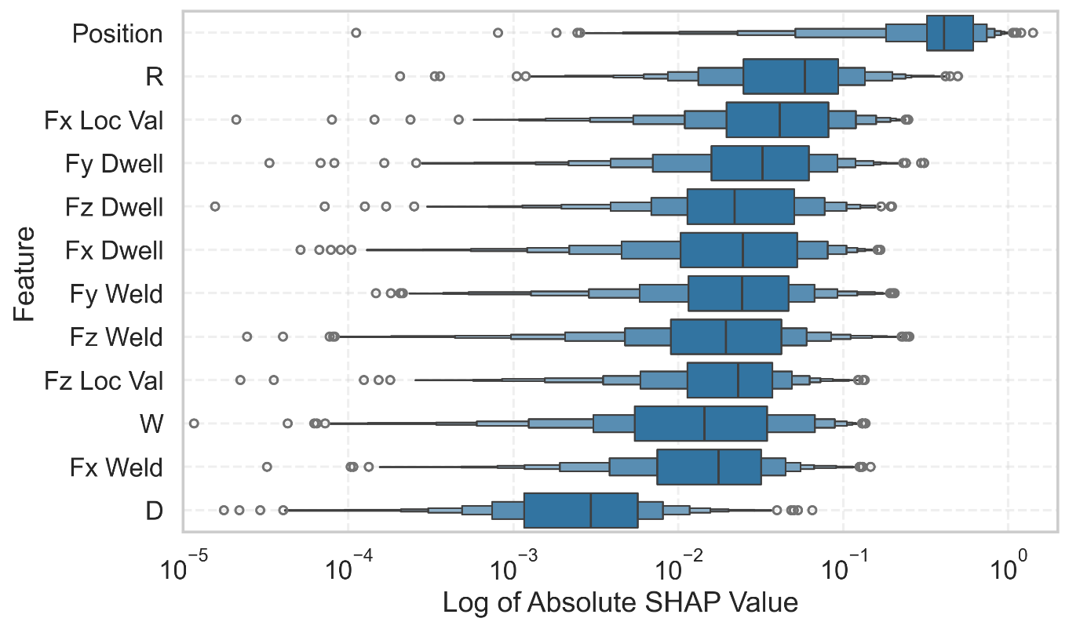
Fig. XX show the log of absolute SHAP value from the top-performing ML models (TabPFN, GBR, XGBR, and RFR). The figure shows the features in desecnding order of median values

